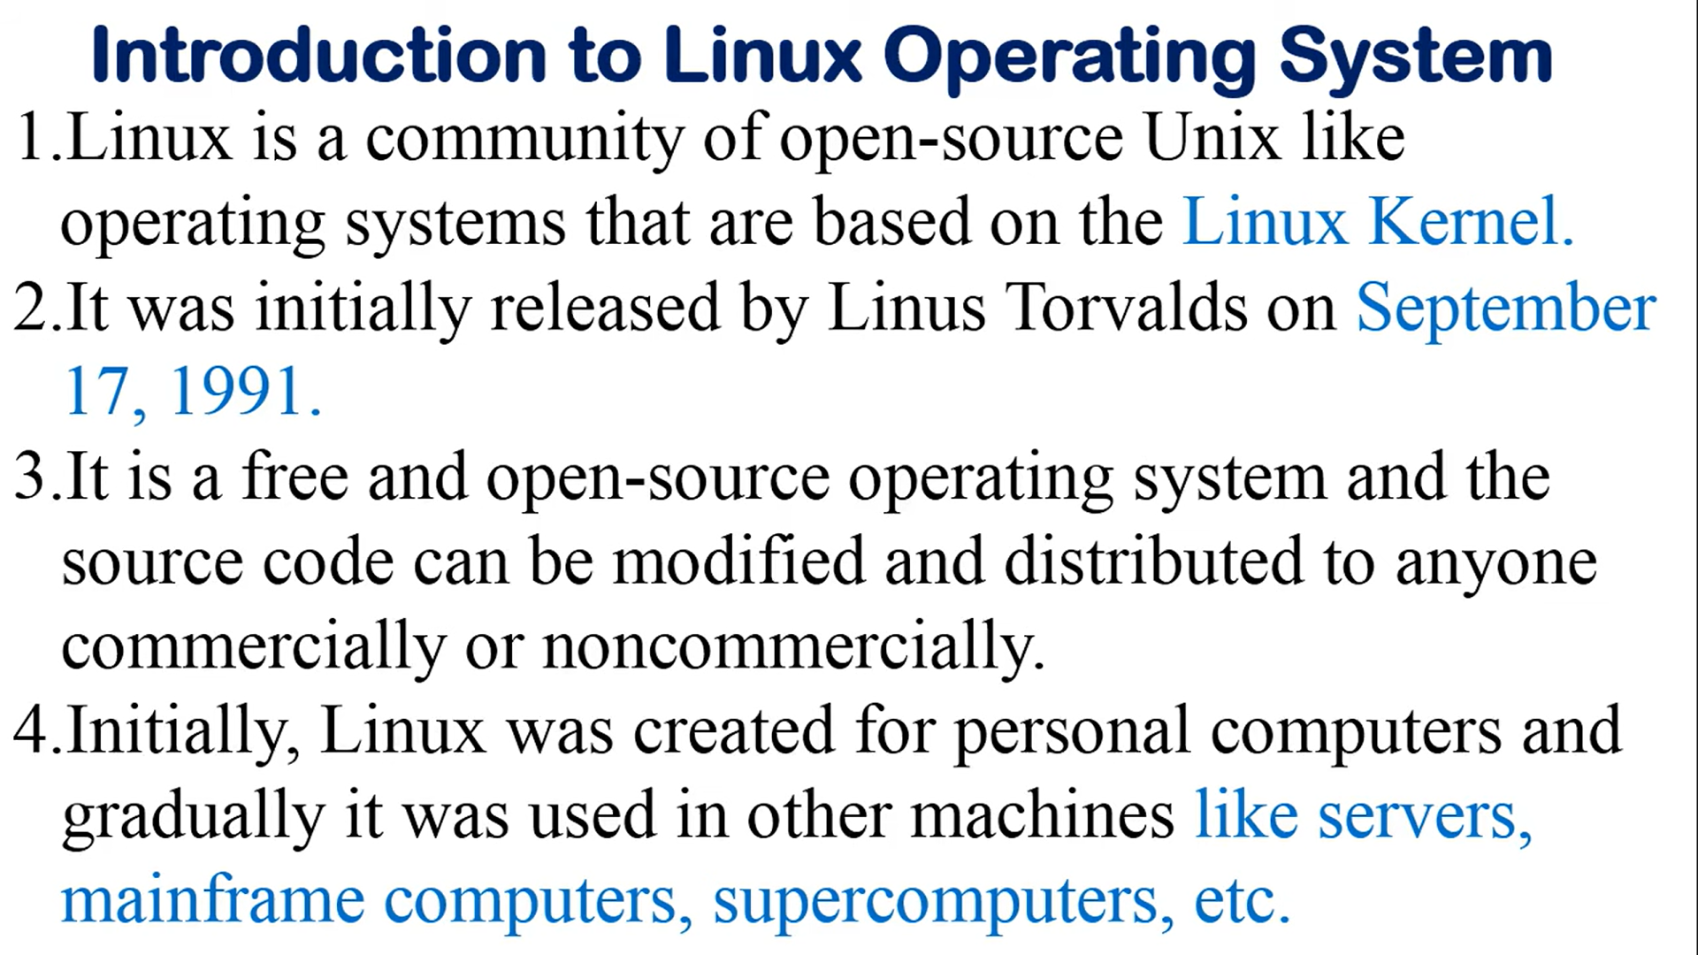

[Introduction to Linux and Basic Linux Commands for Beginners (youtube.com)](https://www.youtube.com/watch?v=IVquJh3DXUA)